***C0374 Mandatory Field***

|  |  |  |  |  |
| --- | --- | --- | --- | --- |
| **Ver** | **Date** | **Author** | **Comments** | **Reviewed by** |
| 1 | 01/12/2020 | Linzi Evans |  | TBC |
| 1.1 | 02/06/2021 | Linzi | Added order types |  |

Requirements 2

Prerequisites 2

Solution Overview 2

Solution Details 2

Security 3

Companies 3

Data Migration 3

Test Steps 3

Technical Implementation 3

Requirements

The Customer PO Number field to be mandatory for all users with a sales / managed services base profile. Pop up to remind users to attach Customers PO document.

Prerequisites

N/A

Solution Overview

Customers PO No. field to be mandatory for site 2012, for all users with a sales profile. Information Message pop up to remind user to attach Customers PO Document.

Solution Details

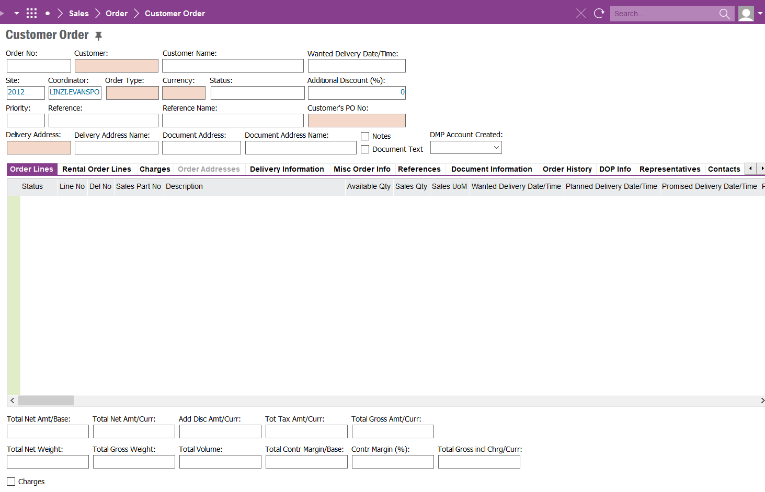

Field is mandatory only if the customer order status is ‘Released’

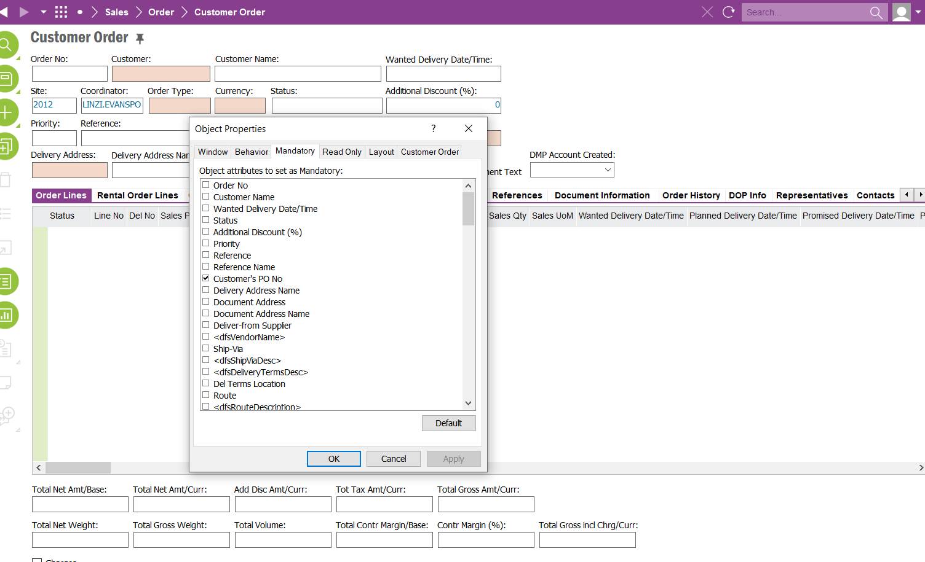

If the Customer’s PO Number field is blank and an attempt is made for the order to be saved the following Validation Error will appear. This only valid for customer orders with order type:

1. BON
2. EQU
3. SIM
4. LAC
5. SUB

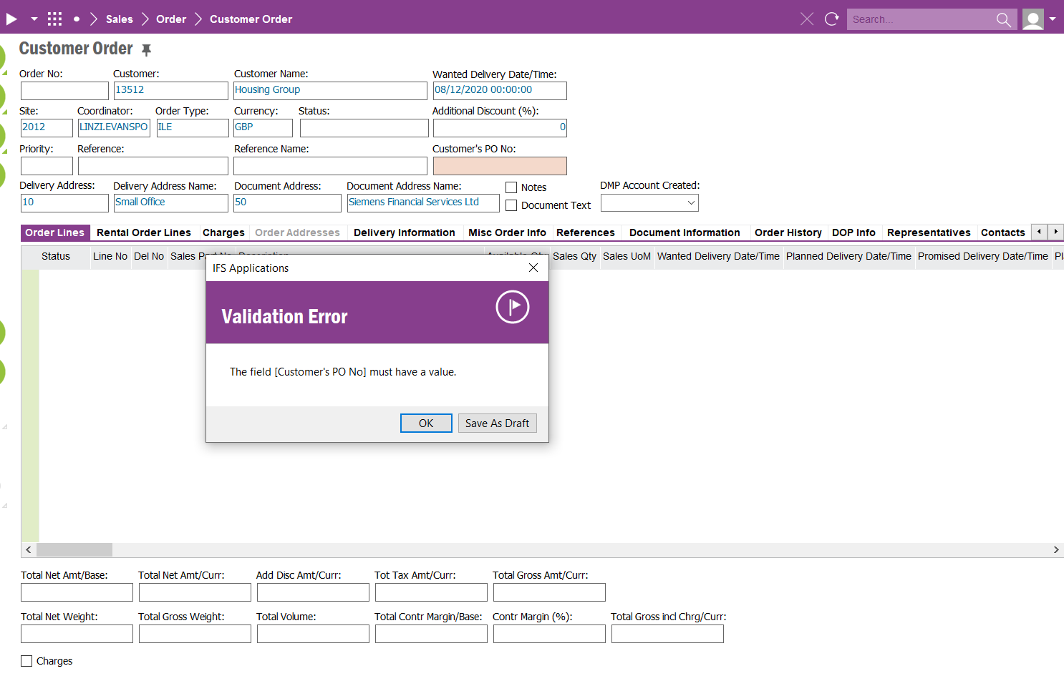

If the Customer’s PO Number has a value entered and the Customer Order is saved and Information Pop up is to appear (no hard stop – just a reminder).

Information Message to say:

**Please attach Customer Purchase Order.**

Field Definitions

<New Field/CLU Definition>

|  |  |  |  |  |  |  |
| --- | --- | --- | --- | --- | --- | --- |
| New DB Object Name | DB Object Item/Field Names | Item Description | Item Data Type | Item Syntax | Calculation Spec, if Derived | LOVs/Enums/Is Mandatory? |
|  |  |  |  |  |  |  |
|  |  |  |  |  |  |  |
|  |  |  |  |  |  |  |
|  |  |  |  |  |  |  |
|  |  |  |  |  |  |  |
|  |  |  |  |  |  |  |
|  |  |  |  |  |  |  |
|  |  |  |  |  |  |  |
|  |  |  |  |  |  |  |
|  |  |  |  |  |  |  |
|  |  |  |  |  |  |  |
|  |  |  |  |  |  |  |

Security

All users with access to Customer Order can access / view and edit this field.

Companies

Applies to the following companies

|  |  |
| --- | --- |
| **Company** | **Required (Y/N)** |
| 1201 | Y |
|  |  |
|  |  |

Data Migration

N/A

Test Steps

<Steps that needs to be taken to test this change. Please provide expected results>

|  |  |  |
| --- | --- | --- |
| **No** | **Script\Test Steps** | **Expected Result** |
| 1 | New Customer Order is created | Customer’s PO Number field requires an entry. |
| 2 | Customer Order is saved | Information Message Pop Up to remind users to attach PO Document. |
|  |  |  |
|  |  |  |
|  |  |  |
|  |  |  |

Technical Implementation

Custom Event – COM_CO_NOTIFICATION

